ANNEX 2

SOCIAL MEDIA POSTS

SOCIAL MEDIA POSTS
Date
Posts #1 - Factsheet: | Volunteering is an opportunity to:  ✔️ Offer help where needed  ✔️ Learn & develop your personal/professional skills  ✔️ Have a real impact  ✔️ Explore new countries, learn about cultures  ✔️ Be part of a community  👉 Click for more info:  https://europa.eu/youth/solidarity_en  #EUSolidarityCorps
Visual | 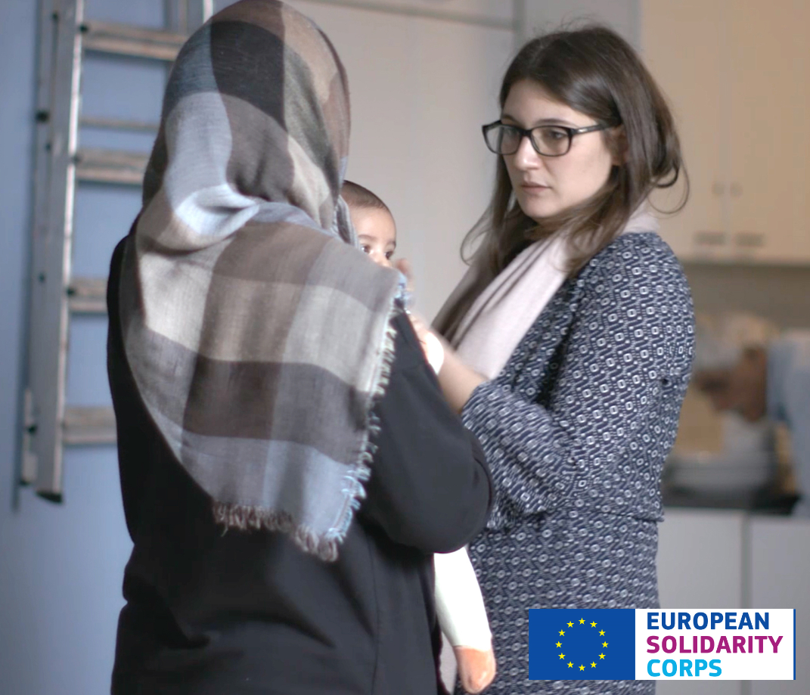

Date
Posts #2 - Animated video: | Have you been selected by an organisation? Congrats! 😊 What happens next? From A to Z, find your answers in this short video 👉 https://www.facebook.com/watch/?v=2158405857803349
Visual | Source file can be obtained on request

Date
Posts #3 - Story: | Being a volunteer can be a turning point in your life! 🌍  Are you still wondering what the benefits of joining the #EUSolidarityCorps are❓  Listen to Dennis Vandrey and see what and how volunteers have developed through this experience👂
Visual | VIDEO + THUMBNAIL TO CHOOSE

Date
Posts #5 - testimonial video Géraldine: | 💬 “As a cultural mediator for asylum seekers and refugees, I felt useful!”  Just like Geraldine, you can have a real impact on people’s life with the #EUSolidarityCorps!💪 See her story and get inspired to participate in the Corps👉 http://bit.ly/EUSolidarityCorps_trainee_Geraldine
Visual | VIDEO

Date
Posts #6 - testimonial video Laura: | 💬“If I hadn’t volunteered at that moment, I would have never done it!”  Have you ever wondered when the best moment to volunteer would be?  👉Watch Laura’s experience at the Red Cross Belgium  👉Tell us why you would want to volunteer!  #EUSolidarityCorps
Visual | VIDEO

Date
Posts #7 – Infographic - Twitter: | Organisations, do you want to be part of the #EUSolidarityCorps?  Click the link to see the 8 steps to follow👣:  👉 [LINK]
Visual Twitter | 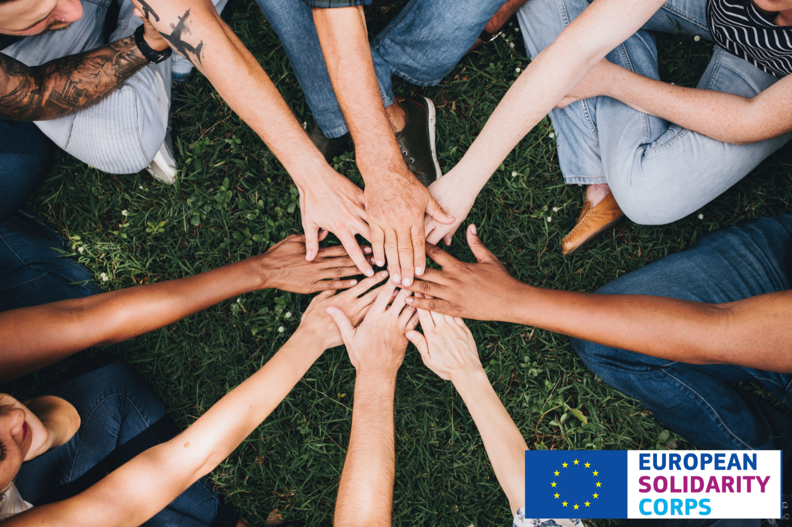
Posts #7 – Infographic – Facebook: | Organisations, here are 8 steps to follow to be part of the #EUSolidarityCorps👣  👉 Check the infographic to know more here:  [LINK]
Visual - [List] | 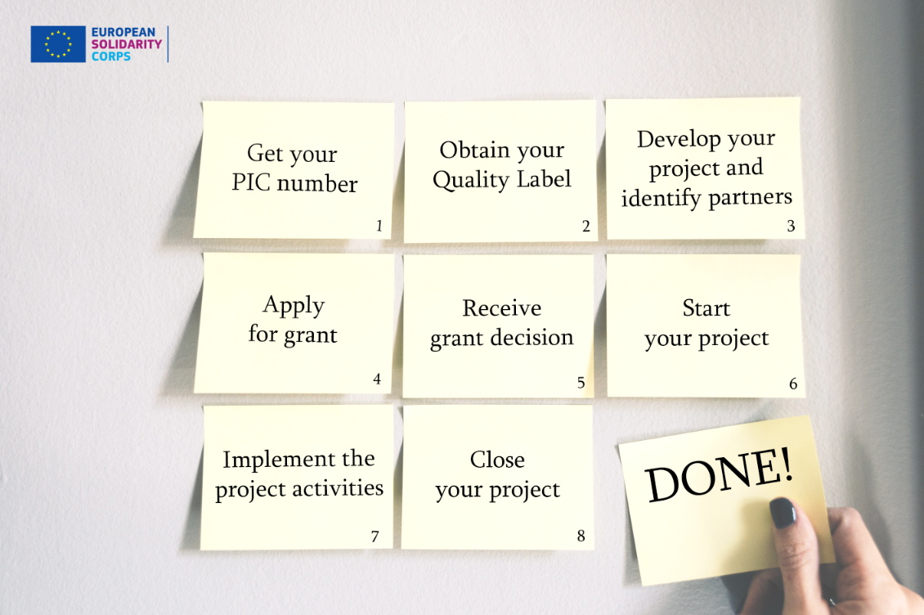

Social media posts for Key messages
Date
Posts #1 – Key message | Why should organisations be part of #EUSolidarityCorps? They  👉bring solidarity to their communities & become international,  👉bring social responsibility into action!  More info here: https://europa.eu/youth/solidarity/organisation
Visual | 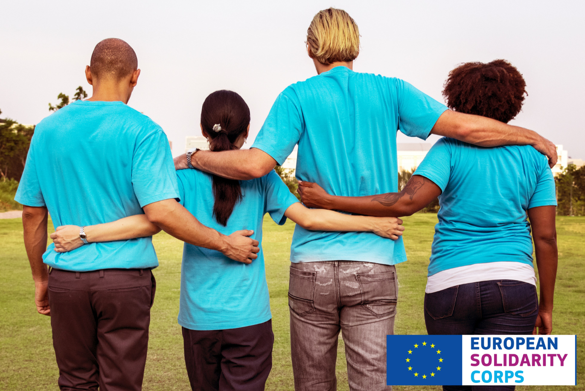

Date
Posts #2 – Key message | Organisations should join the #EUSolidarityCorps to:  💪Empower young people by giving them the opportunity to respond to societal challenges,  💡Be inspired by volunteers & improve in new, innovative and creative ways.  Interested? Find out more here: https://europa.eu/youth/solidarity/organisation_info_en
Visual | 

Date
Posts #3 – Key message | 🏢Which kind of organisations can be part of the #EUSolidarityCorps?  Any! They can be NGOs, local authorities or companies.  ℹ️ What kind of support are they entitled to?  Support if looking for EU funding!  They can ask for help to access EU funding!  Find out more: https://europa.eu/youth/solidarity/organisation_info_en
Visual | 